

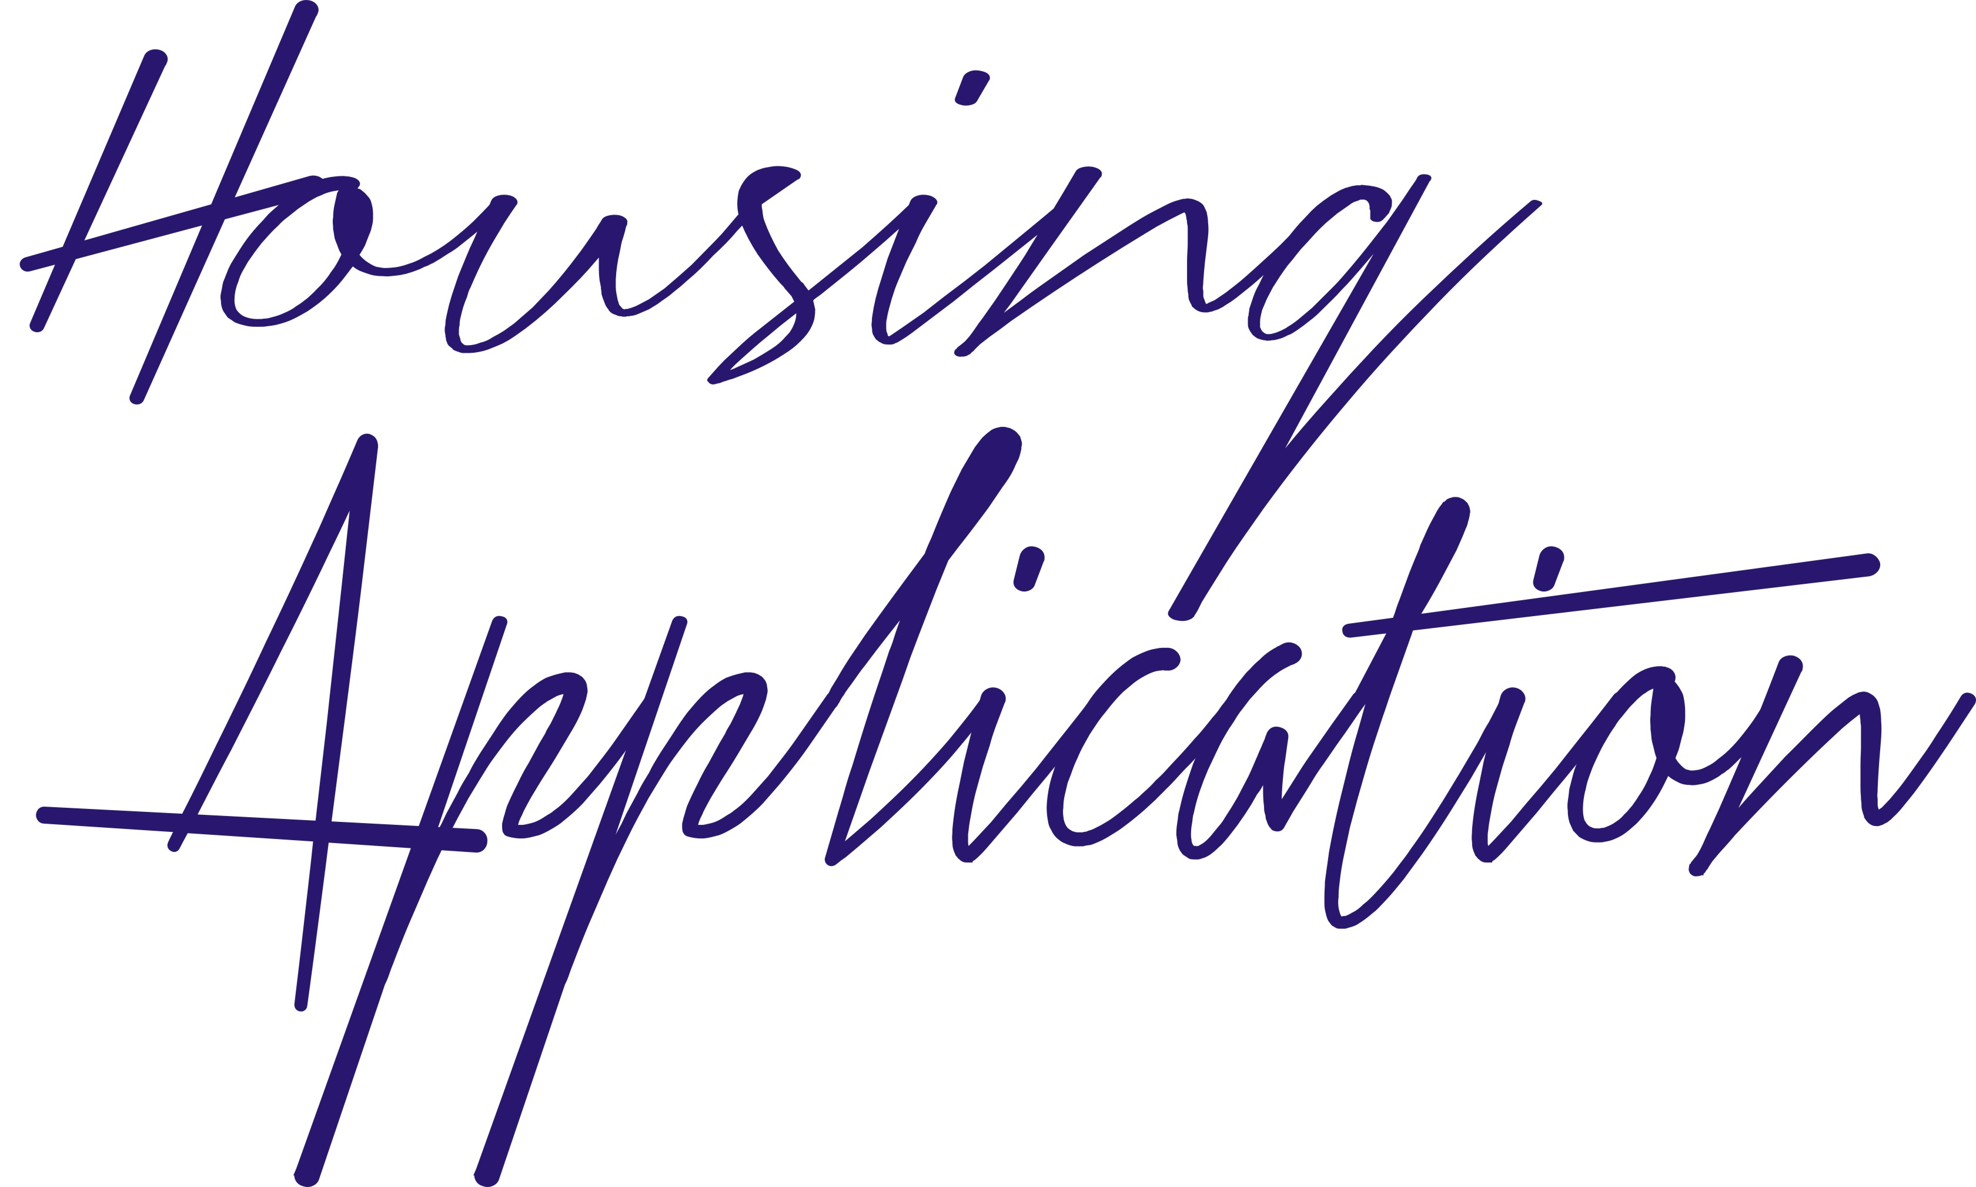



Name.

Please complete all sections in Block Capitals. All new tenancies offered by D.C.H.A. Ltd., will be provisionally offered on a Six Month Assured Shorthold Tenancy. Please note! this application may be subject to interview and or a home visit. Where questions on this form are singular it also means plural. (4/17.14).

Address.

Post Code.

Tel No.
Mob Tel No.

E-Mail.

National Insurance No.

Proof of ID 1.
Proof of ID 2.

ID Checked By.
Applicant’s Date of Birth.

Marital Status.
Number of Children.
Please state the names and D.O.B. of people who will normally reside with you?

Do you keep any pets? If so how many and what kind?

Do you or any person(s) that will be living with you have any convictions or ASBO orders against you/them within the last five years?

Employers Name.

Employers Address.

Employers Telephone No.

Job Title.

No of years service.

Previous Employer. (If unemployed).

Telephone No.

Present Accommodation. (Please tick one box).
Owner Occupier. [ ]
Rented. [ ]
Living In. [ ]
Other (Please state). [ ]

If rented. Please state landlords full
Name, Address and Telephone Number.

How long have you been a tenant of your current landlord?

Do you have any rent arrears with your landlord at the time of completing this form?

If so, how much?
What is the reason for your rent arrears?

Please note! A current rent card must be produced if you live in rented accommodation.

Checked by.

District desired. (Please tick as appropriate).

Binchester. [ ]
Bradley Court. [ ]
Coundon Grange. [ ]
Newfield. [ ]

Please state two people who will support this application. (These people can not be immediate family members).

Application referee no 1.

Application referee no 2.

Any other information you wish to submit in support of this application. (You may use the back of this form is necessary).

DECLARATION. I hereby agree that the information given in this document is true and accurate. I also give Durham County Housing Association Ltd., authorisation to write for references to support this application including those from the Local Authority and or Benefits Agencies. Any fraudulent information supplied will result in this application being void.

Signed.

Date.

Information held by Durham County Housing Association Ltd complies with the Data Protection Act of 1998. The information contained within this document will only be used in support of this application.

..

